

COMPUTER SCIENCE PROJECT

FOR THE YEAR

-2023-2024-

--Submitted by--

Joseph Chacko

Vasudev Dinesh

Sooreya Narayanan MS

<INDEX>

|  |  |  |  |
| --- | --- | --- | --- |
| Sl. No | Title | Pg. No | Signature |
| 1. | Acknowledgments |  |  |
| 2. | Project Description |  |  |
| 3. | Files Used |  |  |
| 4. | Functions & Classes |  |  |
| 5. | Source Code |  |  |
| 6. | Output |  |  |
| 7. | References |  |  |

<Acknowledgments>

I want to express my profound gratitude to God for providing me with the strength and inspiration to embark on this journey. To my dedicated teachers, who imparted knowledge and guidance, I owe a debt of thanks for nurturing my skills. To my supportive friends, you've been my rock and a source of unwavering encouragement. I'm also deeply appreciative of those who provided opportunities that allowed me to pursue my passion. Each of you has played an integral role in the creation of ColdZap, and I'm sincerely thankful for your support.

<Project Description>

ColdZap is an intriguing gaming endeavour meticulously crafted in Python, leveraging the potent pygame library. It falls within the captivating realm of dungeon explorer-style games, where players embark on a thrilling journey through intricately designed levels. However, this game diverges from the mundane; it requires players to not only navigate these treacherous domains but also eliminate all adversaries in their path to unlock access to subsequent levels.

What sets ColdZap apart is its emphasis on strategic thinking and environmental interaction. Success is not solely determined by brute force; instead, players must employ wit and ingenuity to conquer challenges swiftly. Each level presents a puzzle to be solved, requiring players to exploit the surroundings and devise efficient solutions. It's a mental exercise as much as a test of reflexes.

<Files>

|Assets [All asset dependencies needed by the game.]

|-> audio

|--> ...

|

|-> fonts

|--> ...

|

|-> images

|--> ...

|

|GameData [All data related to the game.]

|-> Levels

|--> level0.json

|--> level1.json

|--> level2.json

|--> level3.json

|--> level4.json

|

|-> highscores.json [High Scores]

|-> saves.json [The Savefile.]

|-> settings.json [User Preferences.]

|

|utils [This is a custom library.(Utilities)]

|-> __init__.py

|-> blocks.py

|-> bullet.py

|-> enemy.py

|-> player.py

|-> txt_button.py

|

|drawing_functions.py [Functions dealing with rendering]

|levelCreate.py [A GUI for level creation.]

|main.py [Entry point.]

<Functions &Classes>

<Drawing>

**def** draw_bg(surface):

surface.fill("#baf9ff")

pg.draw.rect(surface, "#a4eeff", (0, 0, 350 *

SCALE * SCALE, 450 * SCALE), 5)

for x, y in [(i, j) for i in range(7) for j in range(9) if (i + j) % 2]:

pg.draw.rect(

surface, "#a4eeff", (50 * SCALE * x, 50 *

SCALE * y, 50 * SCALE, 50 * SCALE))

>> This function takes care of rendering the checker

board background seen behind the game levels.

**def** draw_menu_bg(surface):

surface.fill("#d8fcff")

for x, y in [(i, j) for i in range(7) for j in

range(10) if (i + j) % 2]:

pg.draw.rect(

surface, "#bef3ff", (50 * SCALE * x, 50 *

SCALE * y, 50 * SCALE, 50 * SCALE))

>> The same function but for the menu ( There are

subtle differences in requirements. ).

**def** draw_txt(surface, txt, x, y, color, font, align="center"):

label = font.render(txt, True, color)

rect = (

label.get_rect(center=(x, y))

if align == "center"

else label.get_rect(midleft=(x, y))

)

surface.blit(label, rect)

>> Used To render text onto the screen.

**def** draw_ui(surface, font: pg.font.Font, level, score, lives):

score = "Score: " + str(score)

level = "Level: " + str(level)

pg.draw.rect(surface, "#baf9ff", (0, 450 * SCALE,

350 * SCALE, 50 * SCALE))

draw_txt(surface, str(level), 210 * SCALE, 465 *

SCALE, (0, 0, 0), font, "")

draw_txt(surface, str(score), 210 * SCALE, 490 *

SCALE, (0, 0, 0), font, "")

for i in range(lives):

rect = pg.Rect(60 * SCALE + 25 * SCALE * i,

470 * SCALE, 20 * SCALE, 20 *

SCALE)

pg.draw.rect(surface, (255, 0, 0), rect, 0,

5)

>> Draws the UI elements onto the screen.

**def** fade_to(surface, color, duration):

surf = pg.Surface((700 * SCALE, 500 * SCALE))

surf.fill(color)

for i in range(60):

surf.set_alpha(int(17))

surface.blit(surf, (0, 0))

pg.display.flip()

pg.time.delay(int(duration * 1000 / 60))

>> Used to give a “fade” transition effect.

<Gameplay>

**def** displayBullets(screen):

for i in Bulletlist:

if i.update(screen):

Bulletlist.remove(i)

>> Function to iterate over and display the bullets

(Both player and enemy). Also handles bullet

removal when out of bounds

**def** update_enemies(screen):

hit = False

for i in Enemylist:

if i.update(screen):

hit = True

return hit

>> Function to iterate over all the enemies and

update and draw them

**def** update_collidables(screen):

for i in Collidable_list:

i.update(screen)

>> Function to iterate over and update all collidable

entities.

<Classes>

**class** Wall:

"""

Class for the walls in the game.

:param pos: The position of the wall.

"""

**def** __init__(self, pos):

x, y = pos

self.image = pg.image.load(**f**"assets/images/{SCALE}x/wall2.png")

self.pos = Vector2(x, y)

self.rect = self.image.get_rect(

center=self.pos * 50 * SCALE + Vector2(25, 25) * SCALE

)

self.mask = pg.mask.from_surface(self.image)

Collidable_list.append(self)

**def** update(self, surface):

for i in Bulletlist:

if self.mask.overlap(

i.mask,

(

int(i.pos.x - self.pos.x * 50 * SCALE),

int(i.pos.y - self.pos.y * 50 * SCALE),

),

):

Bulletlist.remove(i)

surface.blit(self.image, self.rect)

>> This class is the blueprint of the walls that make up levels.

>> It contains methods to update and draw the Wall.

**class** Pit:

"""

Class for the pits in the game.

:param pos: The position of the pit.

"""

**def** __init__(self, pos):

x, y = pos

self.image = pg.image.load(**f**"assets/images/{SCALE}x/pit2.png")

self.pos = Vector2(x, y)

self.rect = self.image.get_rect(

center=self.pos * 50 * SCALE + Vector2(25, 25) * SCALE

)

self.mask = pg.mask.from_surface(self.image)

Collidable_list.append(self)

**def** update(self, surface):

surface.blit(self.image, self.rect)

>> This class is the blueprint of the pits that make up

levels.

>> It contains methods to update and draw the Pit.

**class** Bullet:

"""

Class for the bullets in the game.

:param pos: The position of the bullet.

:param vel: The velocity of the bullet. Vector stores both direction

and speed.

:param type: The type of the bullet.

"""

**def** __init__(self, pos, vel, type="red"):

self.type = type

self.image = pg.image.load(**f**"assets/images/{SCALE}x/{type}-bullet.png")

self.pos = pos * 50 * SCALE + Vector2(25, 25) * SCALE

self.vel = vel * SCALE

self.dir = vel.angle_to(Vector2(0, -1))

self.rect = self.image.get_rect(

center=self.pos * 50 * SCALE + Vector2(25, 25) * SCALE

)

self.mask = pg.mask.from_surface(self.image)

**def** update(self, surface):

tempimage = pg.transform.rotate(self.image, self.dir)

self.pos += self.vel

self.rect.center = self.pos

surface.blit(tempimage, self.rect)

if not (0 < self.pos.x < 7 * SCALE * 50 and 0 < self.pos.y < 9 *

SCALE * 50):

return True

>> This class is the blueprint of the bullets that make

shoooting possible

>> It contains methods to update and draw the

Bullets

**class** Enemy:

"""

Class for the enemies in the game.

:param type: The type of the enemy.

:param positions: The positions of the enemy.

"""

**def** __init__(

self,

type: str,

positions: list[list[int, int]],

):

self.type = type

self.positions = positions + positions[::-1]

self.image = pg.image.load(**f**"assets/images/{SCALE}x/{self.type}.png")

self.rect = self.image.get_rect()

self.counter = 0

self.mask = pg.mask.from_surface(self.image)

self.pos = Vector2(self.positions[self.counter])

self.tgt = Vector2(self.positions[1])

self.health = 5

Enemylist.append(self)

**def** update(self, surface):

if self.counter > 120:

self.counter = 0

Bulletlist.append(

Bullet(self.pos, (player.PlayerPos - self.pos).normalize() * 2)

)

self.counter += 1

if (self.tgt - self.pos).length() < 0.05:

self.pos = self.tgt

self.positions.append(self.positions.pop(0))

self.tgt = Vector2(self.positions[0])

self.pos = self.pos + (self.tgt - self.pos) * 0.1

self.rect.center = self.pos * 50 * SCALE + Vector2(25, 25) * SCALE

surface.blit(self.image, self.rect)

self.collision()

if self.health <= 0:

try:

Enemylist.remove(self)

return True

except Exception as e:

pass

**def** collision(self):

for i in Bulletlist:

if i.type == "blue":

if self.mask.overlap(

i.mask,

(

int(i.pos.x - self.pos.x * 50 * SCALE),

int(i.pos.y - self.pos.y * 50 * SCALE),

),

):

Bulletlist.remove(i)

self.health -= 1

>> The core class for all the enemies in the game.

>> It handles enemy behaviour, updation and

drawing.

**class** Player:

"""

INITALIZE THE PLAYER

Syntax: Player(x, y, health)

:param x: x position of the player

:param y: y position of the player

:param health: health of the player

"""

**def** __init__(self, x=3, y=8, health=5):

**global** PlayerPos

self.image = pg.image.load(**f**"assets/images/{SCALE}x/player.png")

self.pos = Vector2(x, y)

self.rect = self.image.get_rect(

center=self.pos * 50 * SCALE + Vector2(25, 25) * SCALE

)

self.moving = False

self.vel = Vector2(0, 0)

self.target = self.pos

self.targets = []

self.mask = pg.mask.from_surface(self.image)

self.health = health

self.counter = 0

self.hit = False

**def** move(self, direction):

match direction:

case "up":

self.targets.append(Vector2(0, -1))

case "down":

self.targets.append(Vector2(0, 1))

case "left":

self.targets.append(Vector2(-1, 0))

case "right":

self.targets.append(Vector2(1, 0))

**def** is_walkable(self, direction, pos=None):

if pos == None:

pos = self.pos

for i in utils.Collidable_list:

if i.pos == pos + direction:

return False

return True

**def** update(self, surface):

**global** PlayerPos

if self.moving:

if (self.target - self.pos).length() < 0.05:

self.pos = self.target

self.moving = False

self.pos = self.pos + (self.target - self.pos) * 0.3

else:

if len(self.targets) != 0:

direction = self.targets.pop(0)

target = self.pos + direction

if (

-1 < target.x < 7

and -1 < target.y < 9

and self.is_walkable(direction)

):

self.target = target

self.moving = True

self.tgt = self.pos

PlayerPos = self.pos

self.rect.center = self.pos * 50 * SCALE + Vector2(25, 25) * SCALE

self.collision()

self.shoot_stuff()

surface.blit(self.image, self.rect)

**def** shoot_stuff(self):

try:

if self.counter > 10:

for enemy in utils.Enemylist:

if self.pos.x == enemy.tgt.x or self.pos.y == enemy.tgt.y:

utils.Bulletlist.append(

utils.Bullet(

self.pos,

(enemy.tgt - self.pos).normalize() * 20,

"blue",

)

)

self.counter = 0

self.counter += 1

except:

pass

**def** collision(self):

for i in utils.Bulletlist:

if i.type == "red":

if self.mask.overlap(

i.mask,

(

int(i.pos.x - self.pos.x * 50 * SCALE),

int(i.pos.y - self.pos.y * 50 * SCALE),

),

):

self.hit = True

utils.Bulletlist.remove(i)

self.health -= 1

>> The core class for hangling the player in the game.

>> It handles input, updation, shooting and drawing.

**class** TxtButton:

"""

INITALIZE THE BUTTON

Syntax: TxtButton(x, y, txt, color, font)

:param x: x position of the button

:param y: y position of the button

:param txt: text to be displayed on the button

:param color: color of the text

:param font: font of the text

"""

**def** __init__(self, x, y, txt, color, font):

self.txt = txt

self.label = font.render(txt, True, color)

self.rect = self.label.get_rect(center=(x, y))

self.bgrect = self.rect.inflate(10, 10)

self.clicked = False

self.color = color

self.font = font

**def** update(self, surface, pos):

action = False

self.label = self.font.render(self.txt, True, self.color)

self.bgrect = self.rect.inflate(10, 10)

self.rect = self.label.get_rect(center=self.rect.center)

mp = pg.mouse.get_pos()

if self.rect.collidepoint(mp):

pg.draw.rect(surface, "#dddddd", self.bgrect)

if self.rect.collidepoint(pos):

action = True

surface.blit(self.label, self.rect)

return action

>> All of the buttons on the menus are instances of

this class.

>> It handles input, updation and drawing.

<Source Code>

<main.py>

import pygame as pg

import sys

from pygame.math import Vector2

import json

import drawing_functions as df

import utils

*# ---INITIALISATION----------------------------*

from utils import SCALE

pg.init()

screen = pg.display.set_mode((int(350 * SCALE), int(500 * SCALE)))

pg.display.set_caption("ColdZap")

*# ---VARIABLES----------------------------------*

quit = False

clock = pg.time.Clock()

*# ---FONTS--------------------------------------*

Comfortaa = pg.font.Font("assets/fonts/Comfortaa.ttf", int(60 * SCALE))

Comfortaa_small = pg.font.Font("assets/fonts/Comfortaa.ttf", int(20 * SCALE))

*# ---MUSIC--------------------------------------*

music_playing = False

current_song = "Nothing"

intro_sound = pg.mixer.Sound("assets/audio/Level-Intro.wav")

*# ---FUNCTIONS----------------------------------*

**def** load_settings():

**global** music_playing, current_song

with open("GameData/settings.json") as f:

settings = json.load(f)

if settings["music"] == 0:

music_playing = False

current_song = "Nothing"

elif settings["music"] == 1:

music_playing = True

current_song = "Astra"

pg.mixer.music.load("assets/audio/Level.mp3")

elif settings["music"] == 2:

music_playing = True

current_song = "Supert"

pg.mixer.music.load("assets/audio/Supert.mp3")

if music_playing:

pg.mixer.music.play(-1)

else:

pg.mixer.music.stop()

load_settings()

*# ---SCREEN-FUNCTIONS---------------------------*

**def** main(saved=False):

utils.Bulletlist.clear()

utils.Enemylist.clear()

utils.Collidable_list.clear()

**def** wincheck():

if not utils.Enemylist:

return True

else:

return False

if saved:

with open("Gamedata/saves.json") as f:

save = json.load(f)

level = save["levelId"]

score = save["score"]

lives = save["lives"]

else:

level = 0

score = 0

lives = 5

with open("Gamedata/saves.json", "w") as f:

json.dump({"levelId": level, "score": score, "lives": lives},

f,indent=4)

with open(**f**"Gamedata/Levels/Level{level}.json") as f:

level_data = json.load(f)

for i in level_data["enemies"]:

utils.Enemy(

level_data["enemies"][i]["type"],

level_data["enemies"][i]["positions"],

)

for i in level_data["wallPositions"]:

utils.Wall(i)

for i in level_data["pitPositions"]:

utils.Pit(i)

startpos = level_data["playerStartPosition"]

player = utils.Player(startpos[0], startpos[1], lives)

**global** quit

**def** event_handler():

for event in pg.event.get():

if event.type == pg.KEYDOWN:

if event.key == pg.K_UP or event.key == pg.K_w:

player.move("up")

elif event.key == pg.K_DOWN or event.key == pg.K_s:

player.move("down")

elif event.key == pg.K_LEFT or event.key == pg.K_a:

player.move("left")

elif event.key == pg.K_RIGHT or event.key == pg.K_d:

player.move("right")

elif event.key == pg.K_ESCAPE or event.key == pg.K_q:

return True

back_button = utils.TxtButton(

20 * SCALE, 480 * SCALE, "<=", (0, 0, 0), Comfortaa_small

)

pg.mixer.music.stop()

intro_sound.play()

pg.mixer.music.load("assets/audio/Level-Theme.wav")

pg.mixer.music.play(-1)

while not quit:

clock.tick(60)

quit = (

pg.event.get(pg.QUIT) or event_handler()

) *# quit if window is closed or event_handler returns True*

df.draw_bg(screen) *# draw background*

utils.update_collidables(screen)

utils.displayBullets(screen)

player.update(screen) *# update player*

if utils.update_enemies(screen):

score += 10 *# update enemies and add 10 to score if enemy is killed*

df.draw_ui(screen, Comfortaa_small, level, score, player.health) *# draw ui*

if back_button.update(

screen, pg.mouse.get_pos() if pg.mouse.get_pressed()[0] else (0, 0)

):

df.fade_to(screen, (0, 0, 0), 0.15)

return menu, ()

if player.health == 0:

with open("Gamedata/saves.json", "w") as f:

json.dump({"levelId": 0, "score": 0, "lives": 5}, f,indent=4)

with open("Gamedata/highscores.json", "r") as f:

highscores = json.load(f)

if score > int(highscores["highscore"]):

with open("Gamedata/highscores.json", "w") as f:

json.dump({"highscore": str(score)}, f,indent=4)

df.fade_to(screen, (0, 0, 0), 0.15)

return you_died, ()

pg.display.flip()

if wincheck():

df.fade_to(screen, (0, 0, 0), 0.5)

if level + 1 == 5:

raise NotImplementedError(**f**"Level {level+1} not implemented yet")

else:

with open("GameData/saves.json", "w") as f:

print(level + 1)

json.dump(

{"levelId": level + 1, "score": score, "lives":

player.health},

f,

indent=4

)

with open("Gamedata/highscores.json", "r") as f:

highscores = json.load(f)

if score > int(highscores["highscore"]):

with open("Gamedata/highscores.json", "w") as f:

json.dump({"highscore": str(score)}, f,indent=4)

return main, (True,)

pg.quit()

sys.exit()

**def** you_died():

menu_button = utils.TxtButton(

175 * SCALE, 450 * SCALE, "Back to menu", (0, 0, 0), Comfortaa_small

)

label = Comfortaa.render("You died", True, (0, 0, 0))

label_rect = label.get_rect(center=(175 * SCALE, 100 * SCALE))

**def** event_handler():

for event in pg.event.get():

if event.type == pg.QUIT:

return True, ()

if event.type == pg.KEYDOWN:

if event.key == pg.K_ESCAPE or event.key == pg.K_q:

return True, ()

if event.type == pg.MOUSEBUTTONDOWN:

return False, event.pos

return False, ()

quit = False

while not quit:

clock.tick(60)

ev = event_handler()

quit = ev[0]

df.draw_menu_bg(screen) *# draw background*

mouse_pos = ev[1] if ev[1] else (0, 0)

screen.blit(label, label_rect)

if menu_button.update(screen, mouse_pos):

df.fade_to(screen, (0, 0, 0), 0.15)

return menu, ()

pg.display.flip()

pg.quit()

sys.exit()

*# ----------------------------------------------*

**def** menu():

**global** quit

load_settings()

**def** event_handler():

for event in pg.event.get():

if event.type == pg.KEYDOWN:

if event.key == pg.K_ESCAPE or event.key == pg.K_q:

return True

elif event.key == pg.K_RETURN:

return False

new_game = utils.TxtButton(

175 * SCALE, 200 * SCALE, "New Game", (0, 0, 0), Comfortaa_small

)

load_game = utils.TxtButton(

175 * SCALE, 250 * SCALE, "Load Game", (0, 0, 0), Comfortaa_small

)

view_highscore = utils.TxtButton(

175 * SCALE, 300 * SCALE, "Highscores", (0, 0, 0), Comfortaa_small

)

settings_button = utils.TxtButton(

175 * SCALE, 350 * SCALE, "Settings", (0, 0, 0), Comfortaa_small

)

quit_game = utils.TxtButton(

175 * SCALE, 400 * SCALE, "Quit", (0, 0, 0), Comfortaa_small

)

while not quit:

clock.tick(60)

quit = (

pg.event.get(pg.QUIT) or event_handler()

) *# quit if window is closed or event_handler returns True*

df.draw_menu_bg(screen) *# draw background*

mouse_pos = (

pg.mouse.get_pos() if pg.mouse.get_pressed()[0] else (0, 0)

) *# get mouse position if mouse is pressed, else (0,0)*

df.draw_txt(screen, "ColdZap", 175 * SCALE, 100 * SCALE, (0, 0, 0), Comfortaa)

if quit_game.update(screen, mouse_pos):

df.fade_to(screen, (0, 0, 0), 0.15)

break

if load_game.update(screen, mouse_pos):

df.fade_to(screen, (0, 0, 0), 0.15)

return main, (True,)

if view_highscore.update(screen, mouse_pos):

df.fade_to(screen, (0, 0, 0), 0.15)

return highscore, ()

if settings_button.update(screen, mouse_pos):

df.fade_to(screen, (0, 0, 0), 0.15)

return settings, ()

if new_game.update(screen, mouse_pos):

df.fade_to(screen, (0, 0, 0), 0.15)

return main, (False,)

pg.display.flip()

pg.quit()

sys.exit()

*# ----------------------------------------------*

**def** highscore():

with open("Gamedata/highscores.json") as f:

highscore = json.load(f)

labels = [

Comfortaa_small.render("Current Highscore", True, (0, 0, 0)),

Comfortaa.render(str(highscore["highscore"]), True, (0, 0, 0)),

]

label_rects = [

labels[0].get_rect(center=(175 * SCALE, 200 * SCALE)),

labels[1].get_rect(center=(175 * SCALE, 250 * SCALE)),

]

menu_button = utils.TxtButton(

175 * SCALE, 450 * SCALE, "Back to menu", (0, 0, 0), Comfortaa_small

)

**def** event_handler():

for event in pg.event.get():

if event.type == pg.QUIT:

return True, ()

if event.type == pg.KEYDOWN:

if event.key == pg.K_ESCAPE or event.key == pg.K_q:

return True, ()

if event.type == pg.MOUSEBUTTONDOWN:

return False, event.pos

return False, ()

quit = False

while not quit:

clock.tick(60)

ev = event_handler()

quit = ev[0]

df.draw_menu_bg(screen) *# draw background*

mouse_pos = ev[1] if ev[1] else (0, 0)

for i in range(len(labels)):

screen.blit(labels[i], label_rects[i])

if menu_button.update(screen, mouse_pos):

df.fade_to(screen, (0, 0, 0), 0.15)

return menu, ()

pg.display.flip()

pg.quit()

sys.exit()

*# ----------------------------------------------*

**def** settings():

**global** quit, current_song

**def** event_handler():

for event in pg.event.get():

if event.type == pg.QUIT:

return True, ()

if event.type == pg.KEYDOWN:

if event.key == pg.K_ESCAPE or event.key == pg.K_q:

return True, ()

if event.type == pg.MOUSEBUTTONDOWN:

return False, event.pos

return False, ()

music_button = utils.TxtButton(

175 * SCALE, 100 * SCALE, **f**"Music : {current_song}", (0, 0, 0), Comfortaa_small

)

menu_button = utils.TxtButton(

175 * SCALE, 150 * SCALE, "Back to menu", (0, 0, 0), Comfortaa_small

)

while not quit:

clock.tick(60)

ev = event_handler()

quit = ev[0] *# quit if window is closed or event_handler returns True*

df.draw_menu_bg(screen) *# draw background*

mouse_pos = (

ev[1] if ev[1] else (0, 0)

) *# get mouse position if mouse is pressed, else (0,0)*

if music_button.update(screen, mouse_pos):

*# cycle through songs*

if current_song == "Nothing":

current_song = "Astra"

with open("GameData/settings.json") as f:

settings = json.load(f)

settings["music"] = 1

with open("GameData/settings.json", "w") as f:

json.dump(settings, f,indent=4)

elif current_song == "Astra":

current_song = "Supert"

with open("GameData/settings.json") as f:

settings = json.load(f)

settings["music"] = 2

with open("GameData/settings.json", "w") as f:

json.dump(settings, f,indent=4)

elif current_song == "Supert":

current_song = "Nothing"

with open("GameData/settings.json") as f:

settings = json.load(f)

settings["music"] = 0

with open("GameData/settings.json", "w") as f:

json.dump(settings, f,indent=4)

load_settings()

music_button.txt = **f**"Music : {current_song}"

if menu_button.update(screen, mouse_pos):

df.fade_to(screen, (0, 0, 0), 0.15)

return menu, ()

pg.display.flip()

pg.quit()

sys.exit()

*# ----------------------------------------------*

*# ---ENTRY-POINT--------------------------------*

if __name__ == "__main__":

active_screen = menu

args = ()

while True:

active_screen, args = active_screen(*args)

*# ----------------------------------------------*

<drawing_functions.py>

import pygame as pg

*# ---VARIABLES----------------------------------*

from utils import SCALE

*# ----------------------------------------------*

*# ---FUNCTIONS----------------------------------*

**def** draw_bg(surface):

surface.fill("#baf9ff")

pg.draw.rect(surface, "#a4eeff", (0, 0, 350 * SCALE * SCALE, 450 * SCALE), 5)

for x, y in [(i, j) for i in range(7) for j in range(9) if (i + j) % 2]:

pg.draw.rect(

surface, "#a4eeff", (50 * SCALE * x, 50 * SCALE * y, 50 * SCALE, 50 *

SCALE)

)

*# ----------------------------------------------*

**def** draw_menu_bg(surface):

surface.fill("#d8fcff")

for x, y in [(i, j) for i in range(7) for j in range(10) if (i + j) % 2]:

pg.draw.rect(

surface, "#bef3ff", (50 * SCALE * x, 50 * SCALE * y, 50 * SCALE, 50 *

SCALE)

)

*# ----------------------------------------------*

**def** draw_txt(surface, txt, x, y, color, font, align="center"):

label = font.render(txt, True, color)

rect = (

label.get_rect(center=(x, y))

if align == "center"

else label.get_rect(midleft=(x, y))

)

surface.blit(label, rect)

*# ----------------------------------------------*

**def** fade_to(surface, color, duration):

surf = pg.Surface((700 * SCALE, 500 * SCALE))

surf.fill(color)

for i in range(60):

surf.set_alpha(int(17))

surface.blit(surf, (0, 0))

pg.display.flip()

pg.time.delay(int(duration * 1000 / 60))

*# ----------------------------------------------*

**def** draw_ui(surface, font: pg.font.Font, level, score, lives):

score = "Score: " + str(score)

level = "Level: " + str(level)

pg.draw.rect(surface, "#baf9ff", (0, 450 * SCALE, 350 * SCALE, 50 * SCALE))

draw_txt(surface, str(level), 210 * SCALE, 465 * SCALE, (0, 0, 0), font, "")

draw_txt(surface, str(score), 210 * SCALE, 490 * SCALE, (0, 0, 0), font, "")

for i in range(lives):

rect = pg.Rect(60 * SCALE + 25 * SCALE * i, 470 * SCALE, 20 * SCALE, 20 *

SCALE)

pg.draw.rect(surface, (255, 0, 0), rect, 0, 5)

*# ----------------------------------------------*

<levelCreate.py>

import pygame as pg

import json

"""

A simple utility to create levels for the game.

"""

LEVEL_ID = 4 *# Change this to the level you want to edit*

IMPLEMENTED_LEVELS = [1, 2, 3, 4] *# Add the levels you have implemented here*

from utils import SCALE

COLORS = [

"white",

"red",

"green",

"blue",

"yellow",

"orange",

"purple",

"pink",

"brown",

"cyan",

]

pg.init()

screen = pg.display.set_mode((int(350 * SCALE), int(450 * SCALE)))

font = pg.font.Font("assets/fonts/Comfortaa.ttf", 20)

bfont = pg.font.Font("assets/fonts/Comfortaa.ttf", 40)

**def** load_tiles(level_id):

data = json.load(open("Gamedata/Levels/level" + str(level_id) + ".json"))

tiles = [Tile(x, y) for x in range(7) for y in range(9)]

for tile in tiles:

if [tile.x, tile.y] in data["wallPositions"]:

tile.txt = "W"

tile.value = REFERENCES["W"](tile.x, tile.y)

elif [tile.x, tile.y] in data["pitPositions"]:

tile.txt = "P"

tile.value = REFERENCES["P"](tile.x, tile.y)

elif [tile.x, tile.y] == data["playerStartPosition"]:

tile.txt = "O"

tile.value = REFERENCES["O"](tile.x, tile.y)

for enemy in data["enemies"]:

enemy = data["enemies"][enemy]

enemy_positions = enemy["positions"]

if enemy_positions[0] == [tile.x, tile.y]:

tile.txt = "E" if enemy["type"] == "glider" else "AE"

tile.value = REFERENCES[tile.txt](tile.x, tile.y, enemy_positions)

return tiles

**def** debug(txt):

screen.blit(font.render(txt, True, "white", "black"), (0, 0))

**def** encode_into(filename, tiles):

data = {

"levelId": 1,

"playerStartPosition": [3, 0],

"pitPositions": [],

"wallPositions": [],

"enemies": {},

}

for tile in tiles:

if tile.txt == "W":

data["wallPositions"].append([tile.value.x, tile.value.y])

elif tile.txt == "P":

data["pitPositions"].append([tile.value.x, tile.value.y])

elif tile.txt == "O":

data["playerStartPosition"] = [tile.value.x, tile.value.y]

elif tile.txt == "E":

data["enemies"]["enemy" + str(len(data["enemies"]) + 1)] = {

"type": "glider",

"positions": tile.value.positions,

}

elif tile.txt == "AE":

data["enemies"]["enemy" + str(len(data["enemies"]) + 1)] = {

"type": "glider-advanced",

"positions": tile.value.positions,

}

json.dump(data, open("Gamedata/Levels/" + filename, "w"), indent=4)

**class** WallTile:

**def** __init__(self, x, y):

self.x = x

self.y = y

**class** PitTile:

**def** __init__(self, x, y):

self.x = x

self.y = y

**class** EnemyTile:

**def** __init__(self, x, y, positions):

self.x = x

self.y = y

self.positions = positions

self.color = COLORS.pop()

print(positions)

**class** PlayerTile:

**def** __init__(self, x, y):

self.x = x

self.y = y

**class** GoalTile:

**def** __init__(self, x, y):

self.x = x

self.y = y

**class** AdvancedEnemyTile:

"""

This class is not used in the game, but it is here for future use.

"""

**def** __init__(self, x, y, positions):

self.x = x

self.y = y

self.positions = positions

**class** Tile:

"""

A tile is a single square on the level editor.

"""

**def** __init__(self, x, y):

self.x = x

self.y = y

self.txt = ""

self.rect = pg.Rect(

10 + self.x * 40 * SCALE, 70 + self.y * 40 * SCALE, 40 * SCALE, 40 *

SCALE

)

self.value = None

**def** update(self):

hover = True if self.rect.collidepoint(pg.mouse.get_pos()) else False

if hover:

pg.draw.rect(screen, "#222222", self.rect)

if self.txt != "":

label = bfont.render(self.txt, True, "white")

labelrect = label.get_rect(center=self.rect.center)

screen.blit(label, labelrect)

pg.draw.rect(screen, "white", self.rect, 1)

if self.txt == "E" or self.txt == "AE":

enemy_paths.append([self.value.positions, self.value.color])

**def** check_click(self):

if self.rect.collidepoint(pg.mouse.get_pos()):

**global** currently_selected

if mode == "enemy" or mode == "advanced_enemy":

if [self.x, self.y] not in positions:

positions.append([self.x, self.y])

elif currently_selected != None:

if str(currently_selected) == "O":

for tile in TILES:

if tile.txt == "O":

tile.txt = ""

tile.value = None

if self.txt == str(currently_selected):

self.txt = ""

self.value = None

else:

self.txt = str(currently_selected)

self.value = REFERENCES[currently_selected.txt](self.x, self.y)

**class** TileSelector:

"""

A tile selector is a single square on the right side of the level editor.

It is used to select a tile to place.

"""

**def** __init__(self, x, y, txt):

self.x = x

self.y = y

self.txt = txt

self.rect = pg.Rect(

30 + self.x * 40 * SCALE, 70 + self.y * 45 * SCALE, 40 * SCALE, 40 *

SCALE

)

**def** __str__(self):

return self.txt

**def** update(self):

hover = True if self.rect.collidepoint(pg.mouse.get_pos()) else False

if hover:

pg.draw.rect(screen, "#222222", self.rect)

pg.draw.rect(screen, "red", self.rect, 1)

label = bfont.render(self.txt, True, "red")

labelrect = label.get_rect(center=self.rect.center)

screen.blit(label, labelrect)

**def** check_click(self):

if self.rect.collidepoint(pg.mouse.get_pos()):

**global** currently_selected, mode, enemy_paths

currently_selected = self

if self.txt == "E" or self.txt == "AE":

if mode == "edit":

mode = "enemy" if self.txt == "E" else "advanced_enemy"

elif (mode == "enemy" or mode == "advanced_enemy") and

any(positions):

x, y = positions[-1]

for tile in TILES:

if tile.x == x and tile.y == y:

found_tile = tile

break

found_tile.txt = str(currently_selected)

found_tile.value = REFERENCES["E" if mode == "enemy" else

"AE"](

x, y, positions.copy()

)

positions.clear()

mode = "edit"

currently_selected = None

else:

mode = "edit"

currently_selected = None

TILE_TYPES = ["W", "P", "O", "E", "AE", "G"]

REFERENCES = {

"W": WallTile,

"P": PitTile,

"O": PlayerTile,

"E": EnemyTile,

"AE": AdvancedEnemyTile, *# This is not used in the game, but it is here for*

*# future use.*

"G": GoalTile,

}

TILES = (

[Tile(x, y) for x in range(7) for y in range(9)]

if LEVEL_ID not in IMPLEMENTED_LEVELS

else load_tiles(LEVEL_ID)

)

TILE_SELECTORS = [

TileSelector(7, y, txt)

for y, txt in enumerate(TILE_TYPES)

if txt not in ["AE", "G"]

]

currently_selected = None

mode = "edit"

positions = []

enemy_paths = []

while True:

enemy_paths = []

for event in pg.event.get():

if event.type == pg.QUIT:

pg.quit()

quit()

if event.type == pg.MOUSEBUTTONDOWN:

for tile in TILES + TILE_SELECTORS:

tile.check_click()

if event.type == pg.KEYDOWN:

if event.key == pg.K_s:

print("Saving...")

encode_into("level" + str(LEVEL_ID) + ".json", TILES)

if event.key == pg.K_ESCAPE:

mode = "edit"

screen.fill("black")

for tile in TILES + TILE_SELECTORS:

tile.update()

for path, color in enemy_paths:

pg.draw.lines(

screen,

color,

False,

[

(x * 40 * SCALE + 10 + SCALE * 20, y * 40 * SCALE + 70 + SCALE *

20)

for x, y in path

],

2,

)

debug(

**f**"Currently selected: {currently_selected} | Mode: {mode} | Positions:

{str(positions)}"

)

pg.display.flip()

<utils/__init__py>

import pygame as pg

*# ---VARIABLES----------------------------------*

SCALE = 1.7

Collidable_list = []

*# ----------------------------------------------*

*# ---CLASSES------------------------------------*

from .txt_button import TxtButton

from .bullet import Bulletlist, Bullet

from .enemy import Enemylist, Enemy

from .player import Player

from .blocks import Wall, Pit

*# ----------------------------------------------*

*# ---FUNCTIONS----------------------------------*

**def** displayBullets(screen):

for i in Bulletlist:

if i.update(screen):

Bulletlist.remove(i)

*# ----------------------------------------------*

**def** update_enemies(screen):

hit = False

for i in Enemylist:

if i.update(screen):

hit = True

return hit

*# ----------------------------------------------*

**def** update_collidables(screen):

for i in Collidable_list:

i.update(screen)

*# ----------------------------------------------*

<utils/blocks.py>

import pygame as pg

from pygame.math import Vector2

from utils import Bulletlist, Collidable_list, SCALE

"""

Contains all the block classes in the game.

"""

**class** Wall:

"""

Class for the walls in the game.

:param pos: The position of the wall.

"""

**def** __init__(self, pos):

x, y = pos

self.image = pg.image.load(**f**"assets/images/{SCALE}x/wall2.png")

self.pos = Vector2(x, y)

self.rect = self.image.get_rect(

center=self.pos * 50 * SCALE + Vector2(25, 25) * SCALE

)

self.mask = pg.mask.from_surface(self.image)

Collidable_list.append(self)

**def** update(self, surface):

for i in Bulletlist:

if self.mask.overlap(

i.mask,

(

int(i.pos.x - self.pos.x * 50 * SCALE),

int(i.pos.y - self.pos.y * 50 * SCALE),

),

):

Bulletlist.remove(i)

surface.blit(self.image, self.rect)

**class** Pit:

"""

Class for the pits in the game.

:param pos: The position of the pit.

"""

**def** __init__(self, pos):

x, y = pos

self.image = pg.image.load(**f**"assets/images/{SCALE}x/pit2.png")

self.pos = Vector2(x, y)

self.rect = self.image.get_rect(

center=self.pos * 50 * SCALE + Vector2(25, 25) * SCALE

)

self.mask = pg.mask.from_surface(self.image)

Collidable_list.append(self)

**def** update(self, surface):

surface.blit(self.image, self.rect)

<utils/bullet.py>

import pygame as pg

from pygame.math import Vector2

from utils import SCALE

Bulletlist = []

"""

This file contains the bullet class.

"""

**class** Bullet:

"""

Class for the bullets in the game.

:param pos: The position of the bullet.

:param vel: The velocity of the bullet. Vector stores both direction and speed.

:param type: The type of the bullet.

"""

**def** __init__(self, pos, vel, type="red"):

self.type = type

self.image = pg.image.load(**f**"assets/images/{SCALE}x/{type}-bullet.png")

self.pos = pos * 50 * SCALE + Vector2(25, 25) * SCALE

self.vel = vel * SCALE

self.dir = vel.angle_to(Vector2(0, -1))

self.rect = self.image.get_rect(

center=self.pos * 50 * SCALE + Vector2(25, 25) * SCALE

)

self.mask = pg.mask.from_surface(self.image)

**def** update(self, surface):

tempimage = pg.transform.rotate(self.image, self.dir)

self.pos += self.vel

self.rect.center = self.pos

surface.blit(tempimage, self.rect)

if not (0 < self.pos.x < 7 * SCALE * 50 and 0 < self.pos.y < 9 * SCALE *

50):

return True

<utils.enemy.py>

import pygame as pg

from pygame.math import Vector2

from utils import Bulletlist, SCALE

from .bullet import Bullet

from . import player

Enemylist = []

"""

Contains all the enemy classes in the game.

"""

**class** Enemy:

"""

Class for the enemies in the game.

:param type: The type of the enemy.

:param positions: The positions of the enemy.

"""

**def** __init__(

self,

type: str,

positions: list[list[int, int]],

):

self.type = type

self.positions = positions + positions[::-1]

self.image = pg.image.load(**f**"assets/images/{SCALE}x/{self.type}.png")

self.rect = self.image.get_rect()

self.counter = 0

self.mask = pg.mask.from_surface(self.image)

self.pos = Vector2(self.positions[self.counter])

self.tgt = Vector2(self.positions[1])

self.health = 5

Enemylist.append(self)

**def** update(self, surface):

if self.counter > 120:

self.counter = 0

Bulletlist.append(

Bullet(self.pos, (player.PlayerPos - self.pos).normalize() * 2)

)

self.counter += 1

if (self.tgt - self.pos).length() < 0.05:

self.pos = self.tgt

self.positions.append(self.positions.pop(0))

self.tgt = Vector2(self.positions[0])

self.pos = self.pos + (self.tgt - self.pos) * 0.1

self.rect.center = self.pos * 50 * SCALE + Vector2(25, 25) * SCALE

surface.blit(self.image, self.rect)

self.collision()

if self.health <= 0:

try:

Enemylist.remove(self)

return True

except Exception as e:

pass

**def** collision(self):

for i in Bulletlist:

if i.type == "blue":

if self.mask.overlap(

i.mask,

(

int(i.pos.x - self.pos.x * 50 * SCALE),

int(i.pos.y - self.pos.y * 50 * SCALE),

),

):

Bulletlist.remove(i)

self.health -= 1

<utils/player.py>

import pygame as pg

from pygame.math import Vector2

import utils

SCALE = utils.SCALE

PlayerPos = Vector2(3, 8)

"""

This file contains the player class.

"""

**class** Player:

"""

INITALIZE THE PLAYER

Syntax: Player(x, y, health)

:param x: x position of the player

:param y: y position of the player

:param health: health of the player

"""

**def** __init__(self, x=3, y=8, health=5):

**global** PlayerPos

self.image = pg.image.load(**f**"assets/images/{SCALE}x/player.png")

self.pos = Vector2(x, y)

self.rect = self.image.get_rect(

center=self.pos * 50 * SCALE + Vector2(25, 25) * SCALE

)

self.moving = False

self.vel = Vector2(0, 0)

self.target = self.pos

self.targets = []

self.mask = pg.mask.from_surface(self.image)

self.health = health

self.counter = 0

self.hit = False

**def** move(self, direction):

match direction:

case "up":

self.targets.append(Vector2(0, -1))

case "down":

self.targets.append(Vector2(0, 1))

case "left":

self.targets.append(Vector2(-1, 0))

case "right":

self.targets.append(Vector2(1, 0))

**def** is_walkable(self, direction, pos=None):

if pos == None:

pos = self.pos

for i in utils.Collidable_list:

if i.pos == pos + direction:

return False

return True

**def** update(self, surface):

**global** PlayerPos

if self.moving:

if (self.target - self.pos).length() < 0.05:

self.pos = self.target

self.moving = False

self.pos = self.pos + (self.target - self.pos) * 0.3

else:

if len(self.targets) != 0:

direction = self.targets.pop(0)

target = self.pos + direction

if (

-1 < target.x < 7

and -1 < target.y < 9

and self.is_walkable(direction)

):

self.target = target

self.moving = True

self.tgt = self.pos

PlayerPos = self.pos

self.rect.center = self.pos * 50 * SCALE + Vector2(25, 25) * SCALE

self.collision()

self.shoot_stuff()

surface.blit(self.image, self.rect)

**def** shoot_stuff(self):

try:

if self.counter > 10:

for enemy in utils.Enemylist:

if self.pos.x == enemy.tgt.x or self.pos.y == enemy.tgt.y:

utils.Bulletlist.append(

utils.Bullet(

self.pos,

(enemy.tgt - self.pos).normalize() * 20,

"blue",

)

)

self.counter = 0

self.counter += 1

except:

pass

**def** collision(self):

for i in utils.Bulletlist:

if i.type == "red":

if self.mask.overlap(

i.mask,

(

int(i.pos.x - self.pos.x * 50 * SCALE),

int(i.pos.y - self.pos.y * 50 * SCALE),

),

):

self.hit = True

utils.Bulletlist.remove(i)

self.health -= 1

<utils/txt_button.py>

import pygame as pg

"""

This file contains the Ui classes.

"""

**class** TxtButton:

"""

INITALIZE THE BUTTON

Syntax: TxtButton(x, y, txt, color, font)

:param x: x position of the button

:param y: y position of the button

:param txt: text to be displayed on the button

:param color: color of the text

:param font: font of the text

"""

**def** __init__(self, x, y, txt, color, font):

self.txt = txt

self.label = font.render(txt, True, color)

self.rect = self.label.get_rect(center=(x, y))

self.bgrect = self.rect.inflate(10, 10)

self.clicked = False

self.color = color

self.font = font

**def** update(self, surface, pos):

action = False

self.label = self.font.render(self.txt, True, self.color)

self.bgrect = self.rect.inflate(10, 10)

self.rect = self.label.get_rect(center=self.rect.center)

mp = pg.mouse.get_pos()

if self.rect.collidepoint(mp):

pg.draw.rect(surface, "#dddddd", self.bgrect)

if self.rect.collidepoint(pos):

action = True

surface.blit(self.label, self.rect)

return action

<Gamedata/highscores.json>

{

"highscore": "0"

}

<Gamedata/saves.json>

{

"levelId": 0,

"score": 0,

"lives": 5

}

<Gamedata/settings.json>

{"music": 1}

<Gamedata/levels/level0.json>

{

"levelId": 1,

"playerStartPosition": [3, 8],

"pitPositions": [

[0, 5],

[1, 5],

[3, 2],

[3, 5],

[5, 5],

[6, 5]

],

"wallPositions": [

[2, 2],

[2, 3],

[2, 4],

[2, 5],

[4, 2],

[4, 3],

[4, 4],

[4, 5]

],

"enemies": {

"enemy1": {

"type": "glider",

"positions": [

[0, 2],

[0, 3],

[0, 4]

]

},

"enemy2": {

"type": "glider",

"positions": [

[1, 4],

[1, 3],

[1, 2]

]

},

"enemy3": {

"type": "glider",

"positions": [

[5, 2],

[5, 3],

[5, 4]

]

},

"enemy4": {

"type": "glider",

"positions": [

[6, 4],

[6, 3],

[6, 2]

]

}

}

}

<Gamedata/levels/level1.json>

{

"levelId": 1,

"playerStartPosition": [3, 8],

"pitPositions": [[5, 5]],

"wallPositions": [[2, 3]],

"enemies": {

"enemy1": {

"type": "glider",

"positions": [

[1, 1],

[2, 1],

[3, 1],

[4, 1],

[5, 1]

],

"speed": 1

},

"enemy2": {

"type": "glider",

"positions": [

[1, 4],

[2, 4],

[3, 4],

[4, 4],

[5, 4]

],

"speed": 1

}

}

}

<Gamedata/levels/level2.json>

{

"levelId": 2,

"playerStartPosition": [3, 8],

"pitPositions": [],

"wallPositions": [

[1, 3],

[5, 3],

[1, 7],

[5, 7]

],

"enemies": {

"enemy1": {

"type": "glider",

"positions": [

[0, 0],

[1, 0],

[2, 0],

[3, 0],

[4, 0],

[5, 0],

[6, 0]

]

},

"enemy2": {

"type": "glider",

"positions": [

[6, 0],

[5, 0],

[4, 0],

[3, 0],

[2, 0],

[1, 0],

[0, 0]

]

},

"enemy3": {

"type": "glider",

"positions": [

[6, 8],

[5, 8],

[4, 8],

[3, 8],

[2, 8],

[1, 8],

[0, 8]

]

},

"enemy4": {

"type": "glider",

"positions": [

[0, 8],

[1, 8],

[2, 8],

[3, 8],

[4, 8],

[5, 8],

[6, 8]

]

},

"enemy5": {

"type": "glider",

"positions": [

[0, 4],

[1, 4],

[2, 4],

[3, 4],

[4, 4],

[5, 4],

[6, 4]

]

},

"enemy6": {

"type": "glider",

"positions": [

[6, 4],

[5, 4],

[4, 4],

[3, 4],

[2, 4],

[1, 4],

[0, 4]

]

}

}

}

<Gamedata/levels/level3.json>

{

"levelId": 1,

"playerStartPosition": [3, 7],

"pitPositions": [

[0, 5],

[1, 2],

[1, 3],

[1, 4],

[1, 5],

[5, 2],

[5, 3],

[5, 4],

[5, 5],

[6, 5]

],

"wallPositions": [[3, 4]],

"enemies": {

"enemy1": {

"type": "glider",

"positions": [

[0, 1],

[0, 2]

]

},

"enemy2": {

"type": "glider",

"positions": [

[0, 3],

[0, 4]

]

},

"enemy3": {

"type": "glider",

"positions": [

[3, 3],

[3, 2],

[3, 1]

]

},

"enemy4": {

"type": "glider",

"positions": [

[6, 1],

[6, 2]

]

},

"enemy5": {

"type": "glider",

"positions": [

[6, 3],

[6, 4]

]

}

}

}

<Gamedata/levels/level4.json>

{

"levelId": 1,

"playerStartPosition": [3, 7],

"pitPositions": [

[1, 2],

[2, 6],

[2, 7],

[3, 6],

[4, 6],

[4, 7],

[5, 2]

],

"wallPositions": [

[0, 4],

[1, 3],

[1, 4],

[3, 2],

[5, 3],

[5, 4],

[6, 4]

],

"enemies": {

"enemy1": {

"type": "glider",

"positions": [

[0, 1],

[0, 2],

[0, 3]

]

},

"enemy2": {

"type": "glider",

"positions": [

[0, 8],

[1, 8],

[2, 8]

]

},

"enemy3": {

"type": "glider",

"positions": [

[2, 3],

[2, 4]

]

},

"enemy4": {

"type": "glider",

"positions": [

[3, 3],

[3, 4]

]

},

"enemy5": {

"type": "glider",

"positions": [

[4, 3],

[4, 4]

]

},

"enemy6": {

"type": "glider",

"positions": [

[6, 1],

[6, 2],

[6, 3]

]

},

"enemy7": {

"type": "glider",

"positions": [

[6, 8],

[5, 8],

[4, 8]

]

}

}

}

<Output>

The following images detail the various scenes obtained during the gameplay of ColdZap.

img-1 – main menu

img-2 – high scores

img-3 – settings menu

img-4 – Lv-1

img-5 – Lv-2

img-6 – Lv-3

img-7 – Lv-4

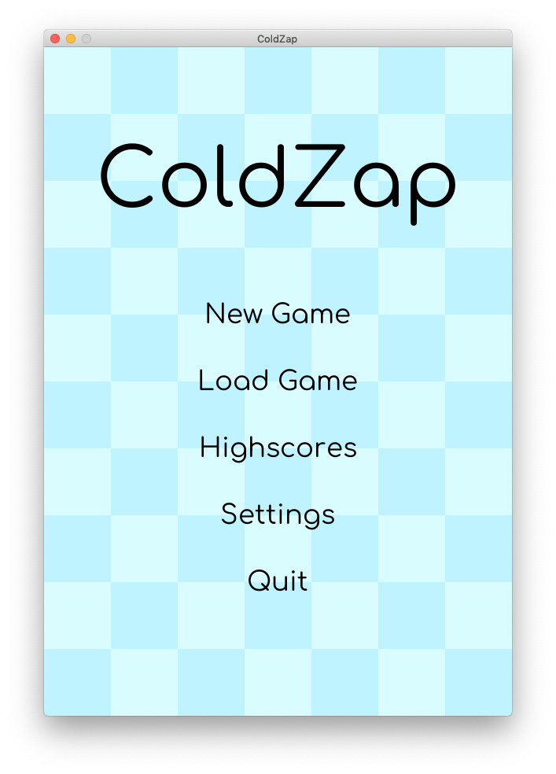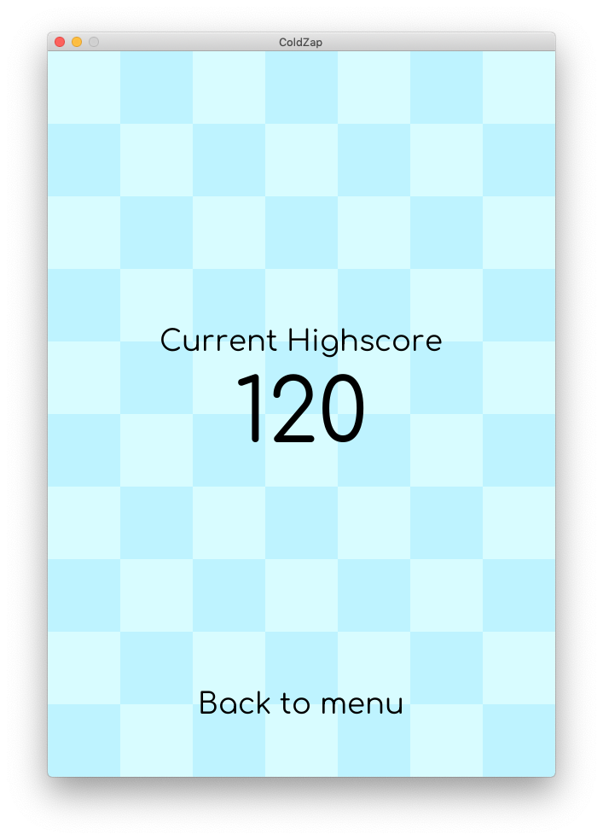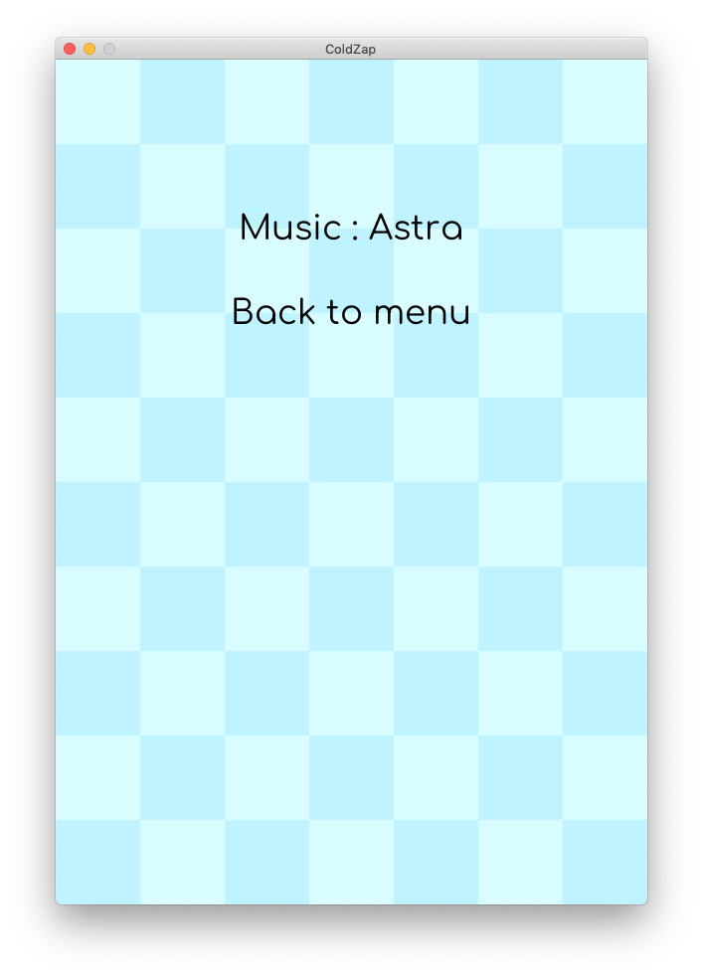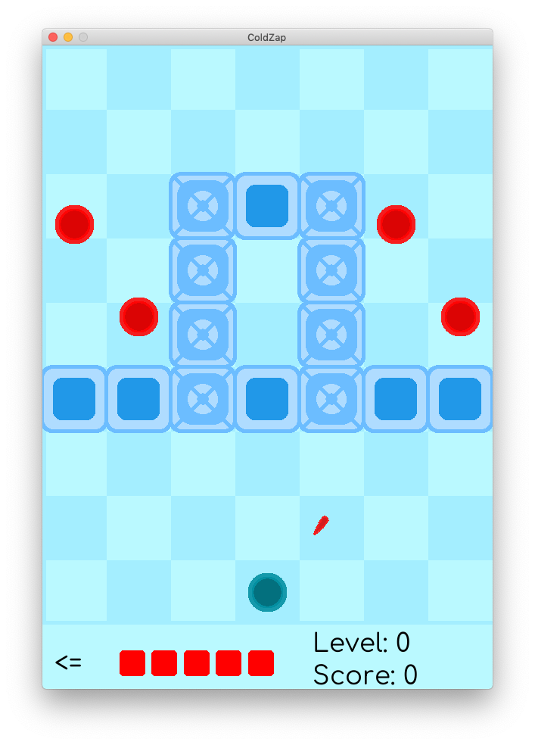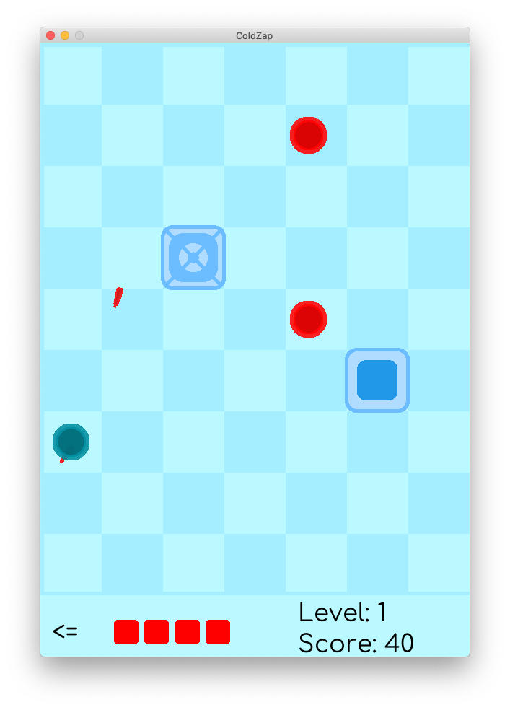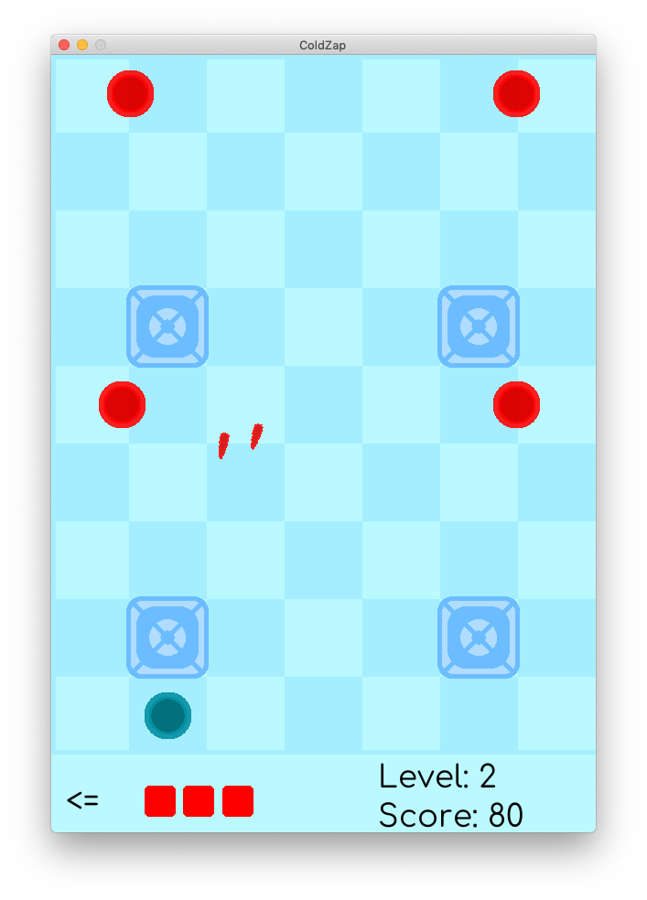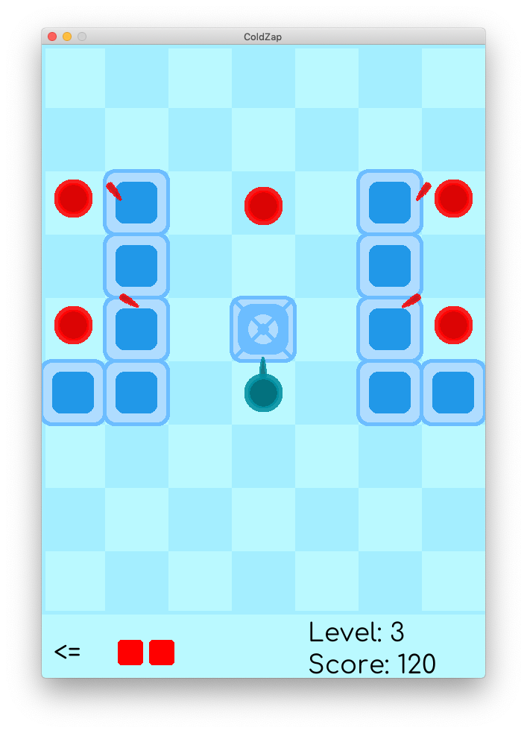

Img-1

Img-2

Img-3

Img-4

Img-5

Img-6

Img-7

<References>

Python – docs.python.org

Pygame – pygame.org/docs/